Lab # 7 SSUET/QR/114

LAB # 7 Generics in Java
OBJECTIVE:
Implementing generic classes and methods for ensuring compile time type safety of data.
LAB TASK:
Write a program that takes integer array, double array and float array. Make a generic function that performs subtraction on array element:
Example: input→ intArray = [5, 7, 3, 9, 19]
Output→ intArray = [2, -4, 6, 10]
Code
package javaapplication1; public class Generic {
// Generic method for subtraction
public static <T extends Number> void subtractArray(T[] array) { System.out.print("Output Array: [ "); for (int i = 0; i < array.length - 1; i++) {
double result = array[i + 1].doubleValue() - array[i].doubleValue(); System.out.print(result + " ");
}
System.out.println("]");
}
public static void main(String[] args) {
Integer[] intArray = {5, 7, 3, 9, 19};
Double[] doubleArray = {2.5, 5.5, 1.5};
Float[] floatArray = {10.0f, 6.0f, 4.0f}; System.out.println("Integer Array:"); subtractArray(intArray);

SWE-312 Software Construction and Development

Lab # 7 SSUET/QR/114

System.out.println("\nDouble Array:"); subtractArray(doubleArray); System.out.println("\nFloat Array:"); subtractArray(floatArray);
}
}

Output:
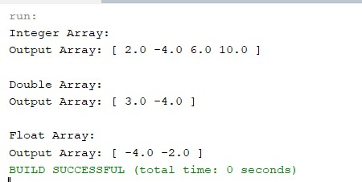

Github:
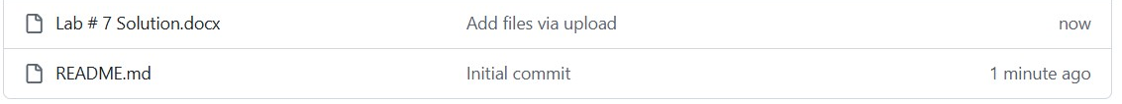

SWE-312 Software Construction and Development

